AUTOMATIC SCREW FEEDER
KFA-0850H (PICK UP TYPE)
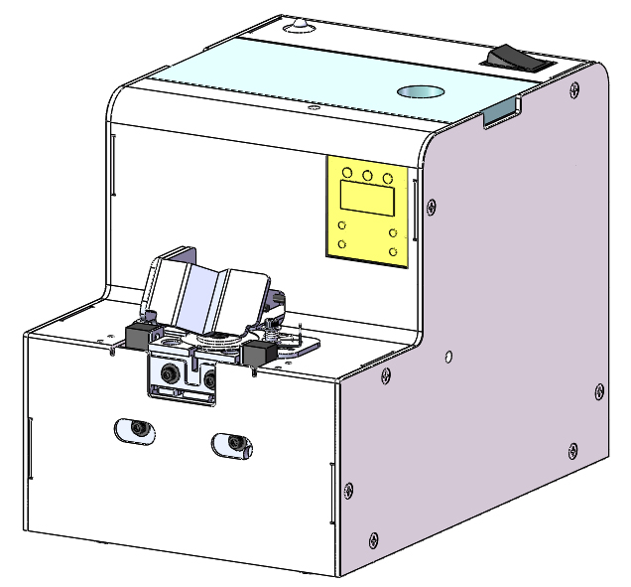
Instruction Manual
（ENGLISH）

Please read this manual thoroughly, before operating the unit and retain it for future reference.
Patented in China, Taiwan, Japan & Korea.
Imitation of product will be caused prosecution.
Y2F152-4-001
SAFETY INSTRUCTIONS

PLEASE NOTE FOLLOWING CONDITIONS BEFORE USING KILEWS KFA-0850
- For a normal performance, please install this machine on a flat and stable working table, do not slant or pad, otherwise machine function might be affected.
- Turn off the power switch and unplug the AC adaptor when this machine is not being used for a period of time.
- To avoid damage and malfunction, use the AC adaptor supplied with this machine only.
- Keep the surface of the rail groove clean and free from dust and oil. Failure to keep the rail groove clean could result in damage to the machine.
- The applied screws must be clean without grease or dust, and screw size is within specified range as machine rail.
- Handle screws on rails with care, do not use excess force to remove them or the rails may be damaged.
- When scooping chamber is turning, do not put fingers or objects other than screws into the chamber.
- Do not turn ON the power switch before the rails are set properly for operation.
- In case of malfunction during operation, please turn off the power and unplug the AC adaptor. Contact your supplier at once.
Whenever this machine requires service, please contact your supplier for assistance, or go to our website & e-mail us your contact detail and requirement, we will respond ASAP.

CONTENTS
CHECK BEFORE OPERATION…………………………..………………………1
ACCESSORIES INCLUDED…………………………………………………….1
CHECK THE SCREW SIZE ………………………..……………………..…1
FUNCTIONS WITH ADJUSTING HOLES ON HOUSING AND PCB ……... .2
ADJUSTMENT………………………………………………………………………3
ADJUST THE RAIL ASSEMBLY…………………………………………………3
DISMANTLE THE RAIL ASSEMBLY………………………………………….3
ADJUST THE WIDTH OF RAIL ASSMEBLY…………………………………6
INSERT THE RAIL ASSEMBLY……………………………………………….8
ADJUST THE HOLDING PLATE……………………………………………….10
ADJUST THE FEEDING STRUCTURE……………………………………….11
ADJSUT THE SENSOR FUNCTION…………………………………………..13
ADJUST THE V CHASE ON ROLLER......……………………………………14
ADJUST THE BRUSH…………………………………………………………..15
OPERATION METHOD……………………………………………………………16
LOAD SCREWS INTO CHAMBER…………………………………………….16
PICKING UP SCREW…………………………………………………………...17
COUNTER INTERFACE OPERATION………………………………………18~20.
MAINTENANCE & TROUBLE SHOOTING……………………………….……21
MAINTENANCE & CLEANING…………………………………………………..22
INTERNATIONAL WARRANTY CONDITIONS………………………………...23~24

CHECK BEFORE OPERATION

ACCESSORIES INCLUDED

Please check if there are complete accessories included with your KFA-0820H:
HEX Wrench 2.0*107mmL Type*1 | Power Controller AC 100~240V/DC12V*1
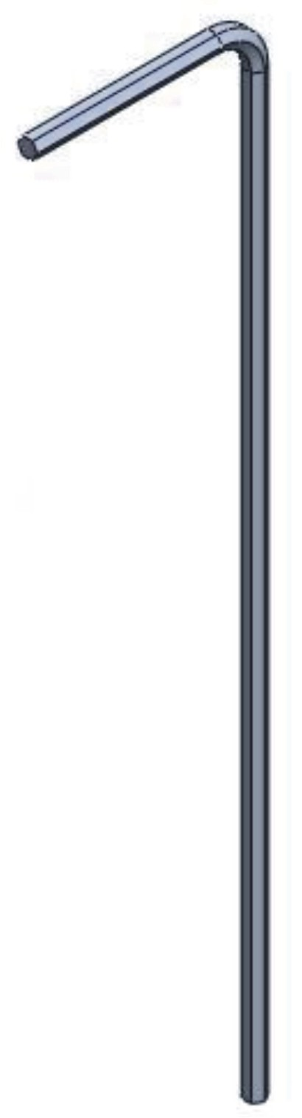 | 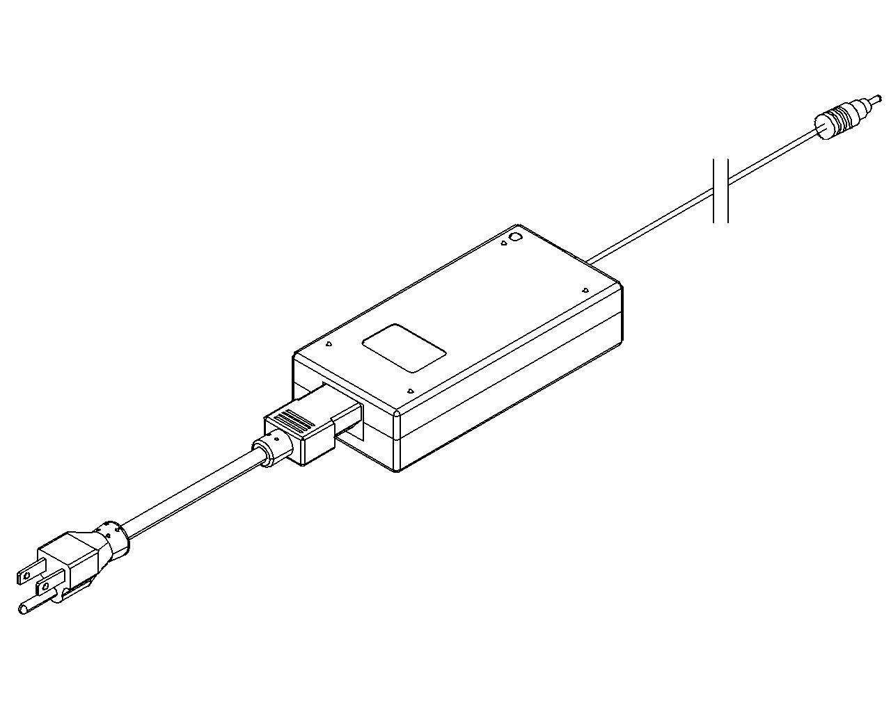
Orbit Back-End Chip Rule 20*10*0.2mm*2pcs&0.5mm*6pcs | Orbit Front-End Chip Rule 20*10*0.2mm*2pcs&0.5mm*6pcs
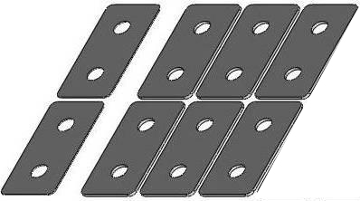 | 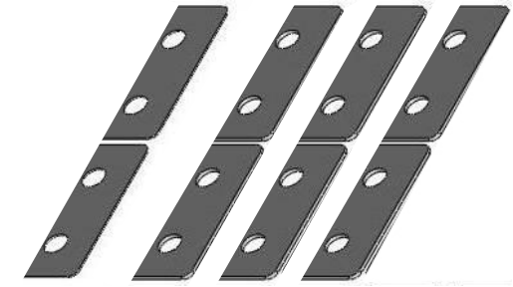
Instruction Manual*1


CHECK THE SCREW SISE
Measure the size precisely on each part of applied screw with a caliper.
Table A
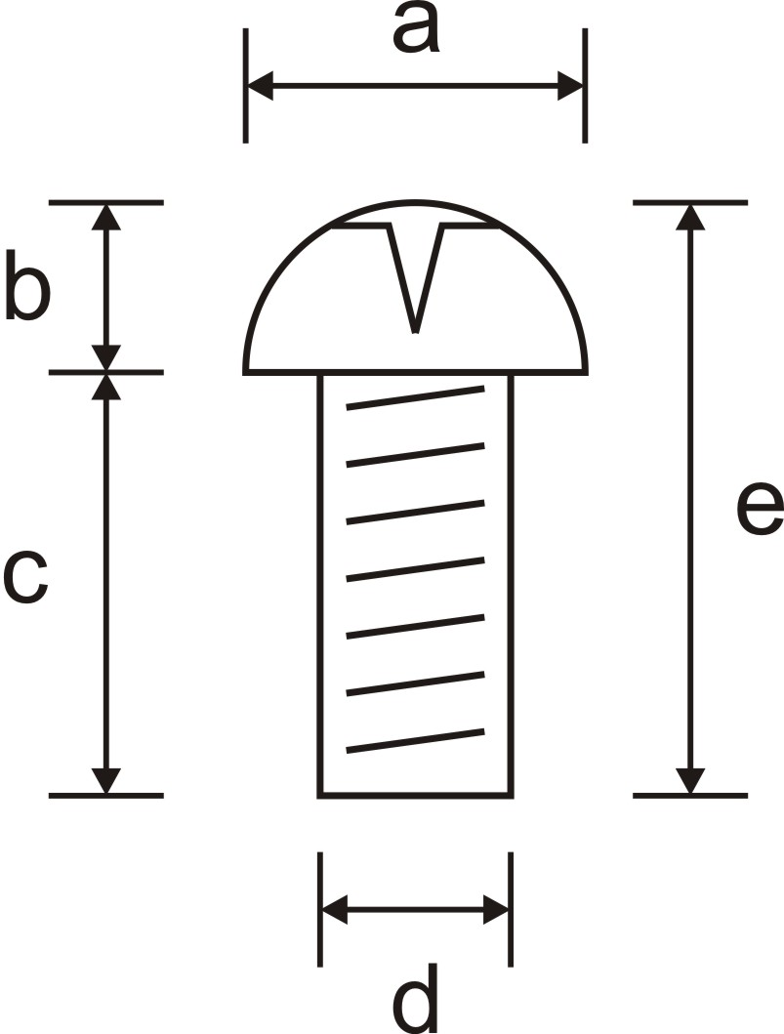
a | Dia. of screw head
b | Height of screw head
c | Length of screw body
d | Dia. of screw bolt
e | Total length of screw

FUNCTION WITH ADJUSTING HOLES ON HOUSING AND PCB

C.
B.
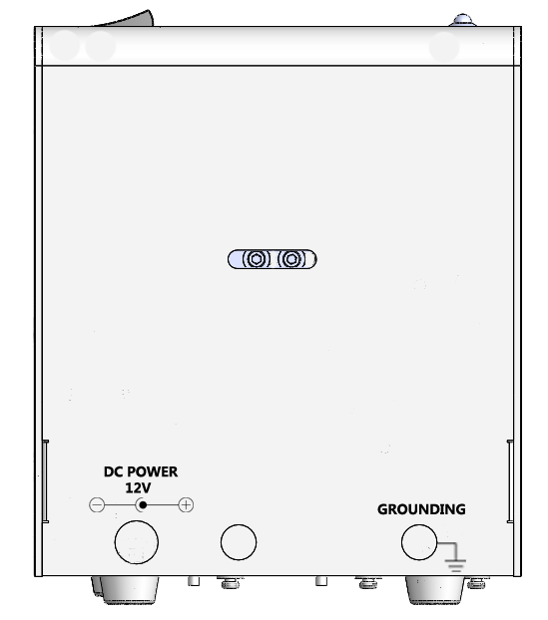
A.
D.
E.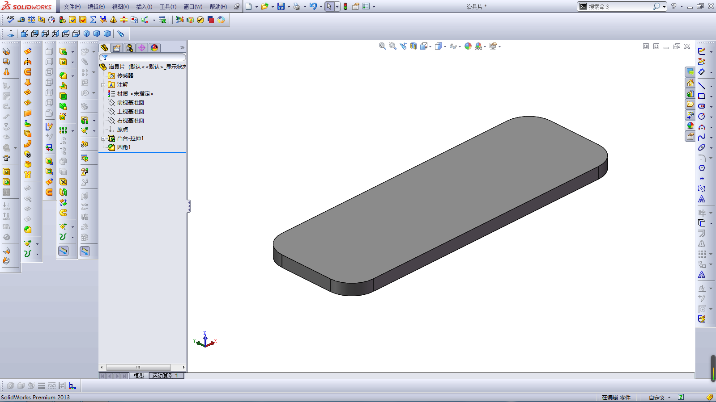.
A.

A. Lock Gate Plate
B. Power S.W.
C. Indication Light
D. DC Power Hole
E. Grounding Hole

※ Attention ※
a. Part F, G, H are installed and set properly by Kilews, please do not adjust by your own.
b. Part F、G、H are installed in the inside of PCB, please do not use any tools and adjust it by
your own to avoid damage the VR.

ADJUSTMENT
After checking the screw size, it needs to adjust all related parts according to the screw size for the first use.

軌道調整

ADJUST THE RAIL ASSEMBLY
- Remove the fixing screws of guide assembly, dismantle the guide assembly.

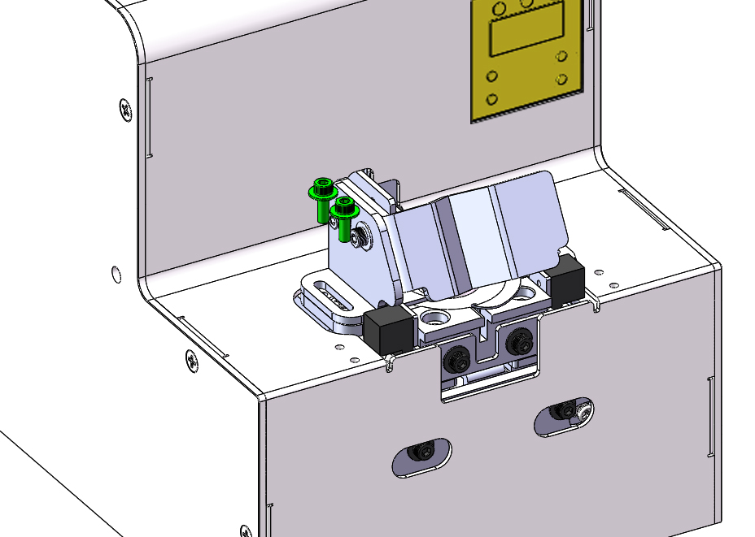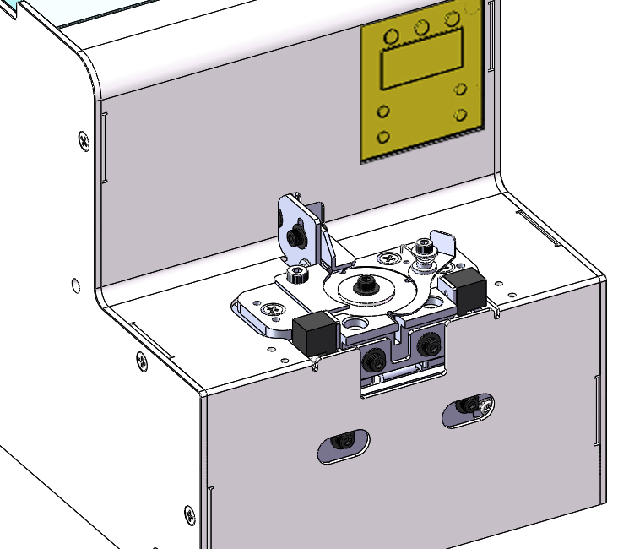

- Remove the fixing screws (6pcs) of front housing, and take off the front
housing.

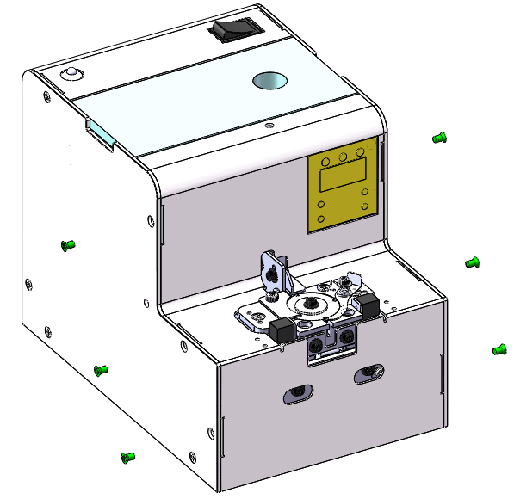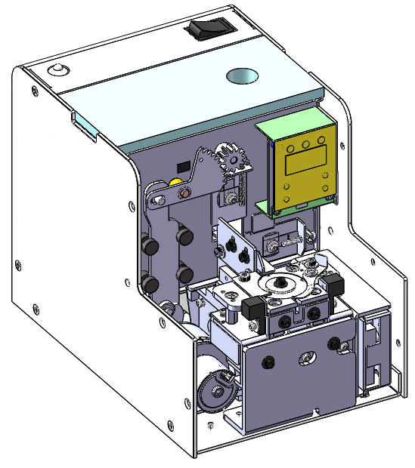

3. Dismantle the fixing screws (4pcs) of feeding structure, and take it off.
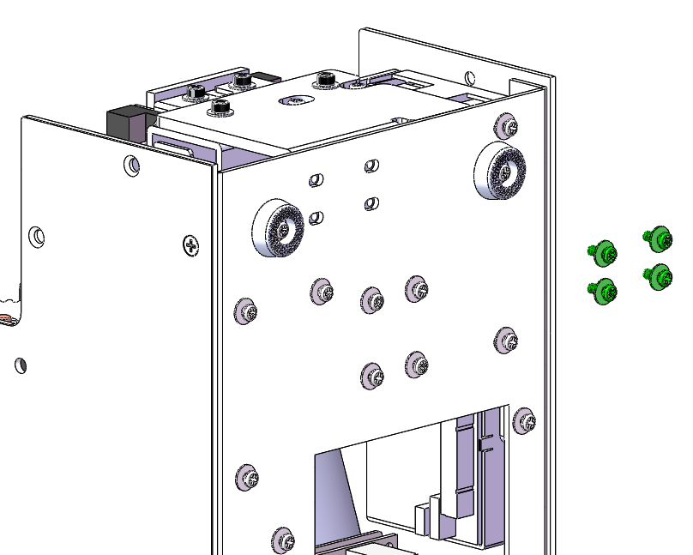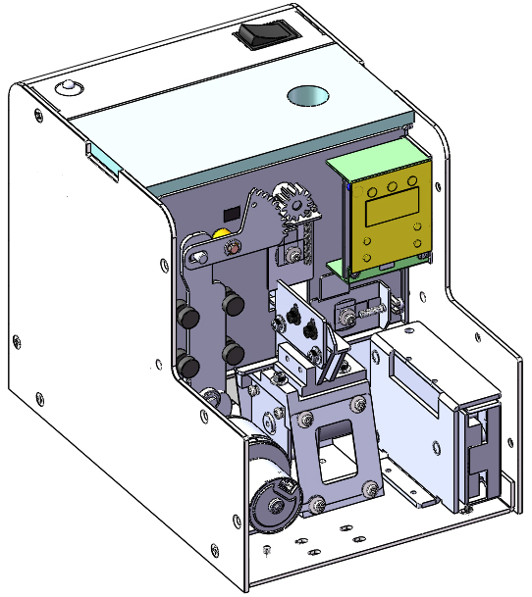

- Facing the machine, use Hex wrench to loose the screw clockwise to open
the lock gate upward.

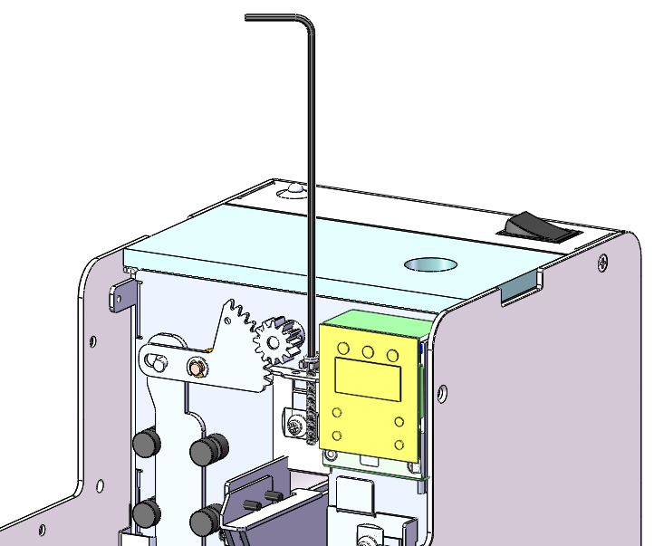

5. Facing the machine, use Hex wrench to loose the screw clockwise to open the lock gate rightward.

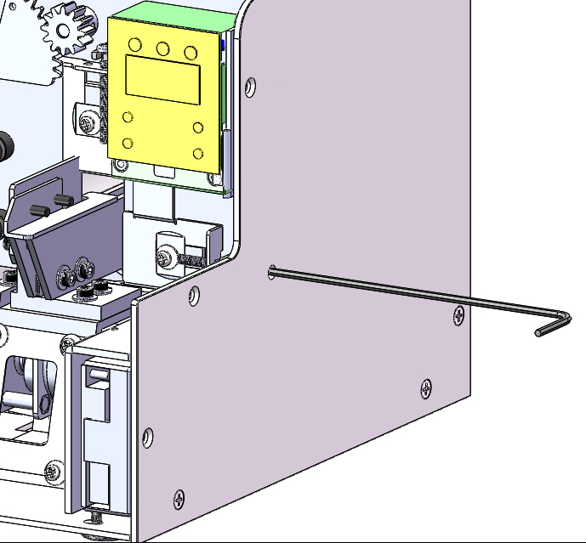

6. Remove the fixing screws of rail assembly
The fixing screws of rail assembly
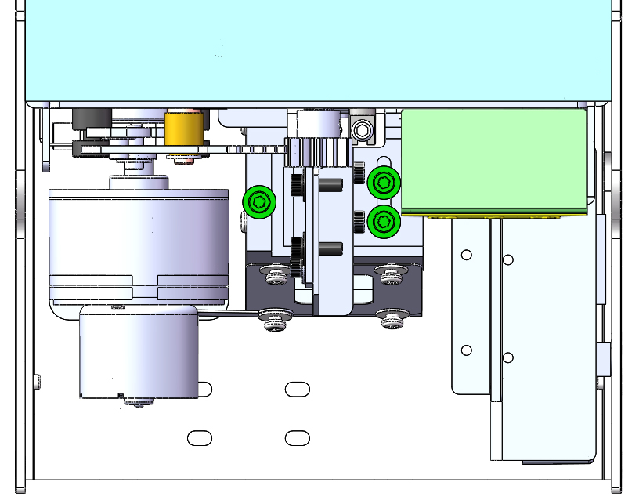

7. Draw out the rail assembly from the machine.
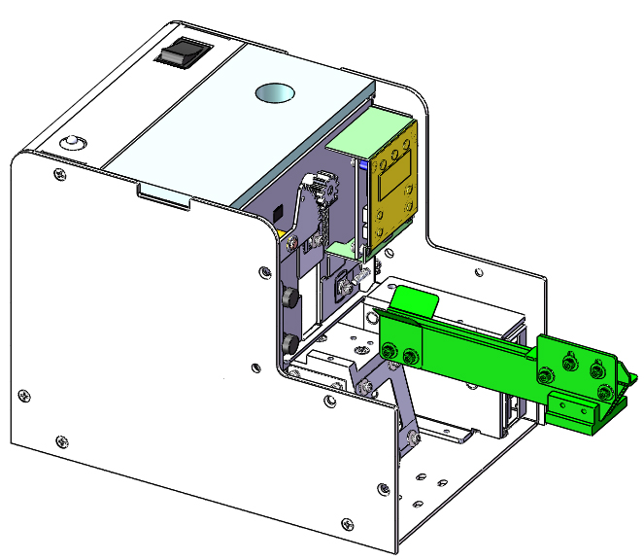

※NOTE THE FOLLOWING WHEN MAKING ABOVE ADJUSTMENT※
- Before dismantle the rail assembly, please confirm the lock gate status is open.

ADJUST THE WIDTH OF RAIL ASSEMBLY
- Remove the fixing screws on the front end of rail assembly.
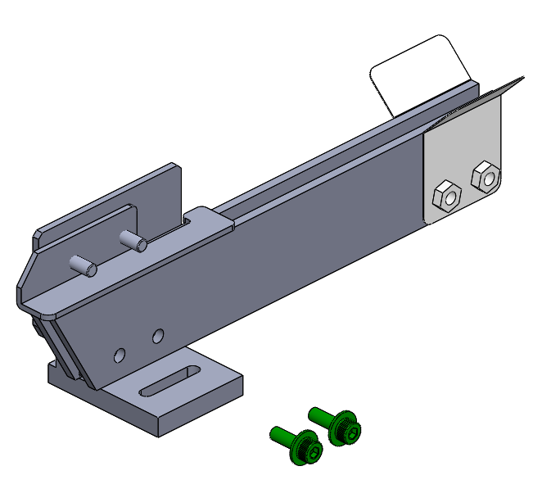

- Remove the fixing screw on the rear end of side of rail assembly, take off the tooling plate

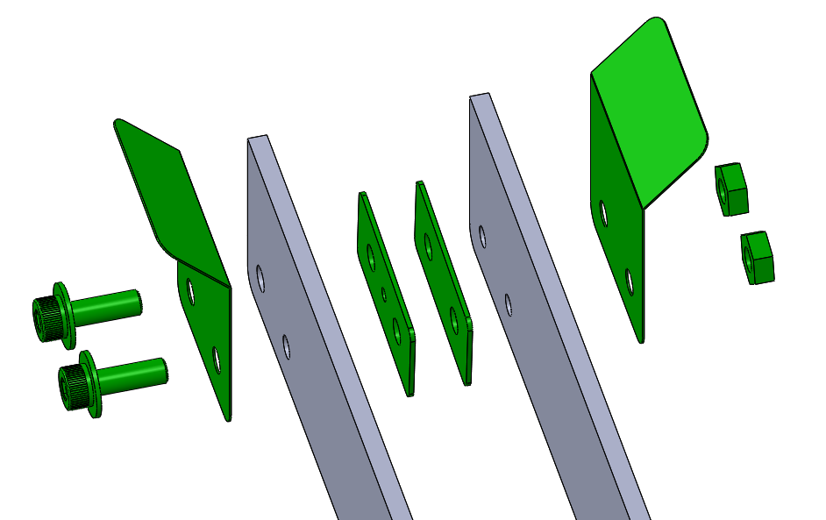

- According to Table b, insert the suitable tooling plate into the rail groove for the width required and tighten the screw of step 1.2.
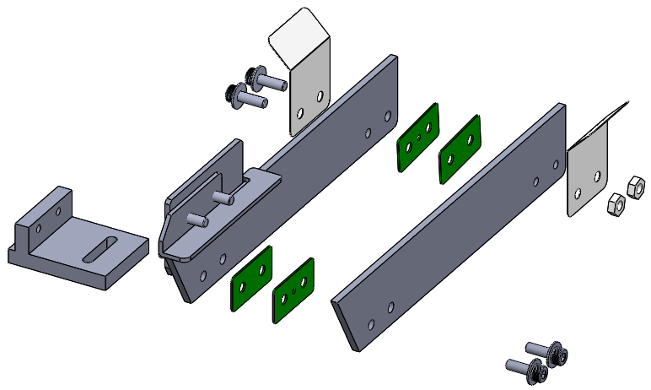
※ COMBINATION OF THE THICKNESS FOR REFERENCE ※Table b
Dia. of Screw Bolt (d) mm | Accessory-Tooling  Plate (Rear) mm | Dia. of Screw Bolt (d) mm | Accessory-Tooling Plate (Rear) mm
1.2 | 0.5*2+0.2*2=1.4 | 2.5 | 0.2 + 0.5 * 5 = 2.7
1.4 | 0.2*3+0.5 *2 = 1.6 | 3.0 | 0.2 + 0.5 * 6 = 3.2
1.7 | 0.2 * 2 + 0.5 * 3 = 1.9 | 3.5 | 0.2 + 0.5 * 7 = 3.7
2.0 | 0.2 + 0.5 * 4 = 2.2 | 4.0 | 0.2 + 0.5 * 8 = 4.2
2.3 | 0.5 * 5 = 2.5 | 5.0 | 0.2+ 0.5 * 10 = 5.2
- After width adjustment of the rail assembly, take one screw into the groove and slide it up and down to both sides. Then check whether the movement is smoothly.
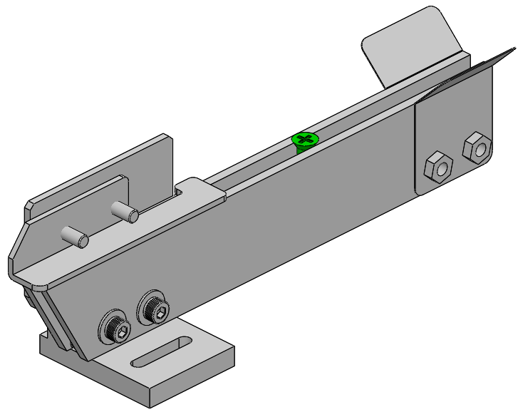
※ NOTE THE FOLLOWING WHEN MAKING ABOVE ADJUSTMENT※
a. Please be sure to keep the width of rail from the beginning to the end uniformly.
b. When adjusting the width of front rail assembly, the screw of step 1 must be fastened tightly.

INSTALL THE RAIL ASSEMBLY
- Insert the adjusted rail assembly into the machine. Then fasten the fixing screws.

- Install the feeding structure, and then fasten screws.

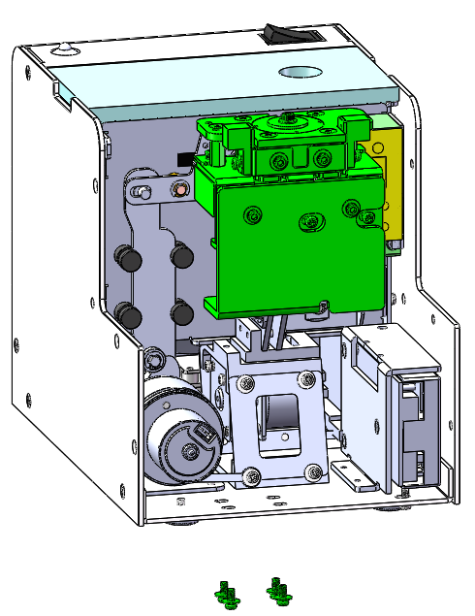

- Adjust up and right gate to make distance between rail and gate around 0.2~0.5mm.
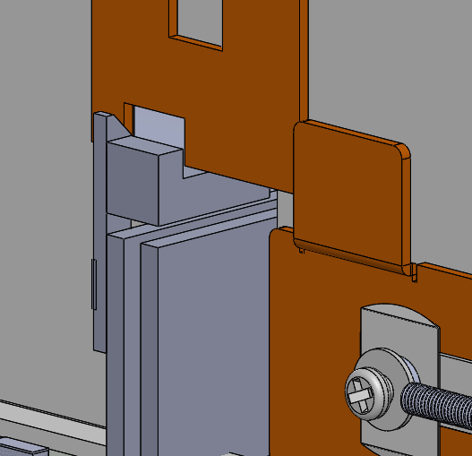
0.2~0.5mm

- Loosen rail fixing screw, adjust distance between the front of rail and
disc around 0.2~0.5mm, fasten the screw.
0.2~0.5mm
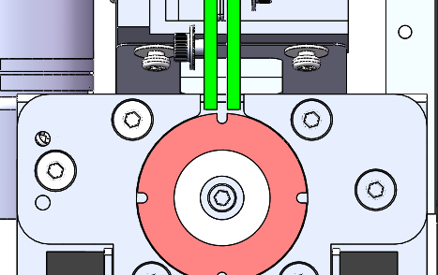

※ NOTE
- Rail installation must keep 0.2~0.5mm gap with disc, must not be touched.
- When rail cannot install successfully, please check.
- Must keep 0.2~0.5mm gap between up、right gate and rail.

Force-down plate adjustment
- Loosen fixing screw on force-down plate.
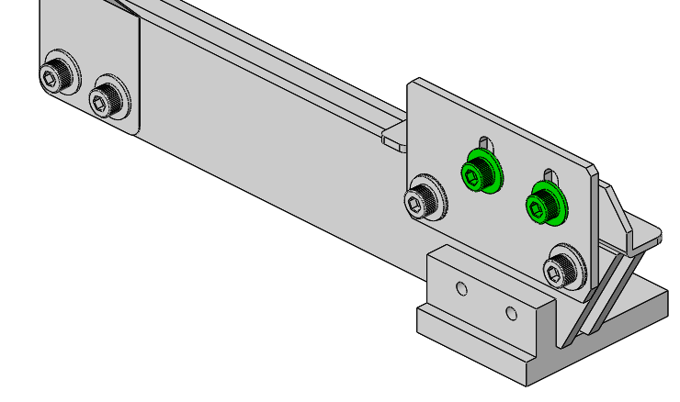
- Use accessory tooling plate adjust height of force-down plate and then
fasten screw in step1.
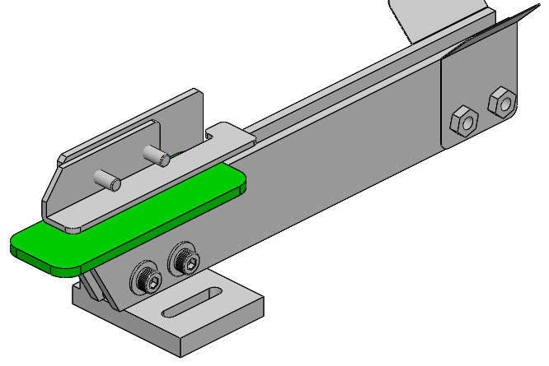
- Put some screws into the groove and slide it up, to check whether the movement is smooth.
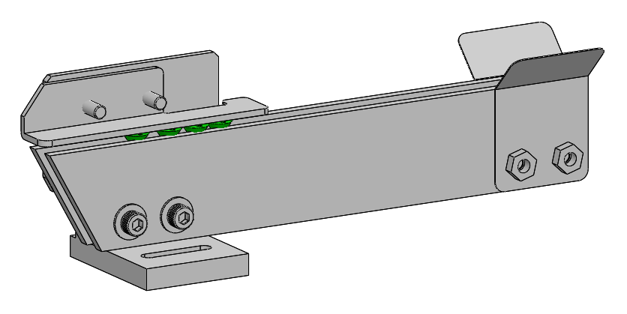
※ NOTE
a. When adjust force-down plate, the screw in step 1 must fasten tightly to avoid loosing.

Distribution Mechanism adjustment
- Loosen fixing screw from front of distribution mechanism.
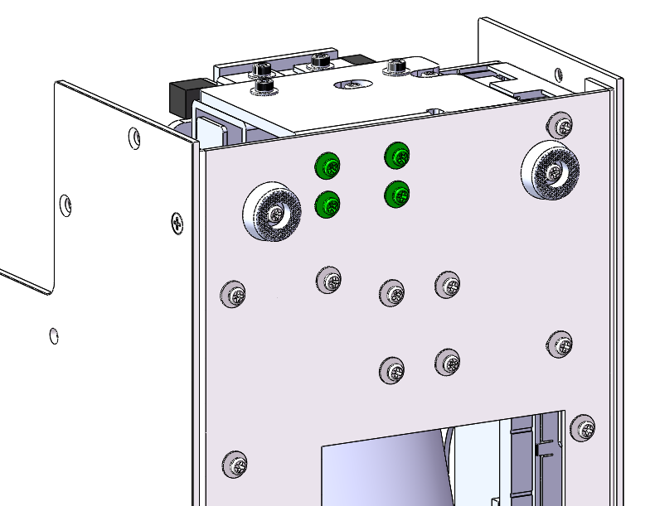

- Align disc gap with central of rail by adjust front of distribution mechanism
by left and right, fasten the loosen screw in step 1.

- Loosen two hexagon screws.

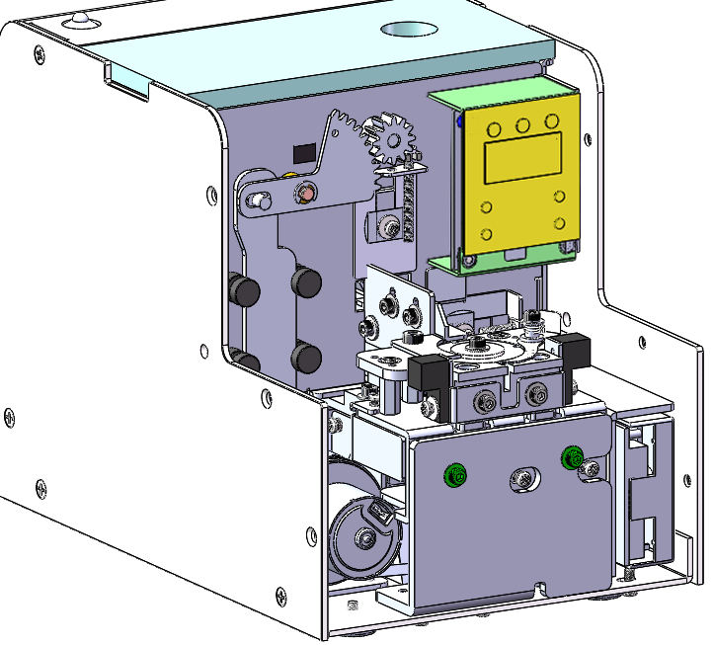

- Adjust from part by up and down to make disc and rail flush, and then fasten loosen screw in step 3.
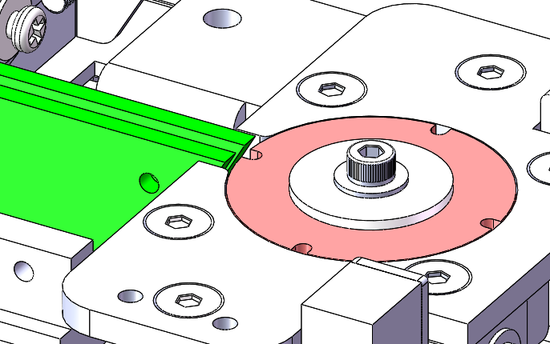
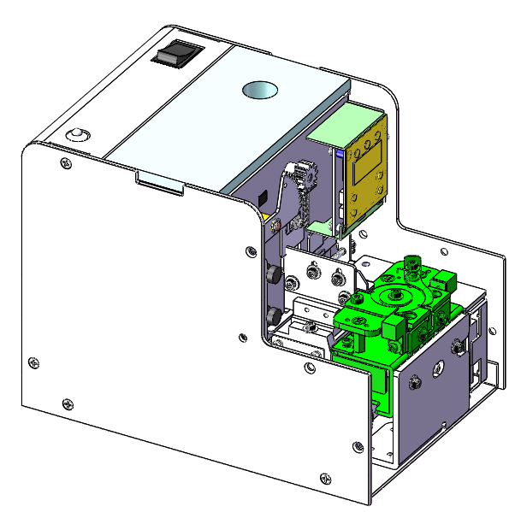
Flush

※ NOTE ※
- Align disc gap with central of rail, and upper plane cannot higher than
upper plane of front rail.
- Disc plane cannot higher than rail plane.

Adjust Sensor Function
- Loosen the fixing screw of sensor fixing plate

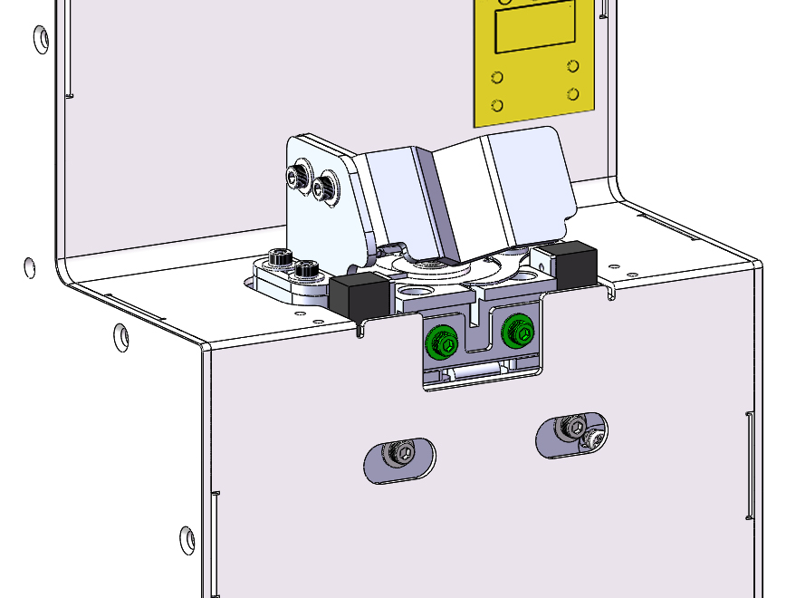

- Make sure to cover half of the hole, and then fasten the screw of step 1.

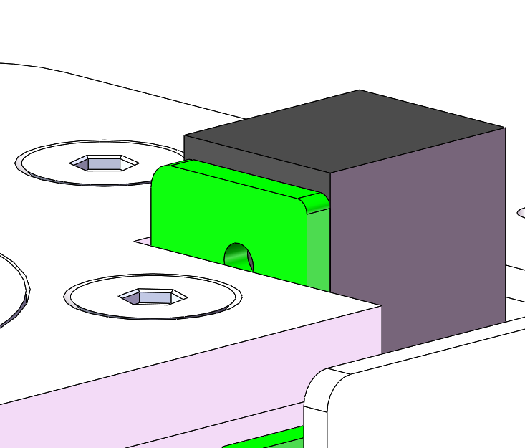

※ NOTICE ※
a. Make sure to cove half of the hole, and do adjustment to ensure the sensor function no problem.

Adjust V Chase on Scooping Chamber Back
The V Chase is locate on top of the rail, and fastened to the back of Roller Assembly. The purpose is to catch fallen screws from the Rollers, and guide screws back to the rail.

- Using the Allen wrench to loosen the Hex Socket Head Cap Screws behind the main body
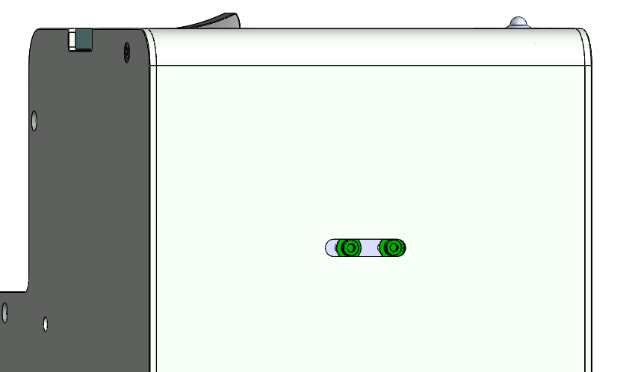

- Adjust V Chase to face to the center of the rail. Distance between Chase and rail should be 0.8~1.0mm
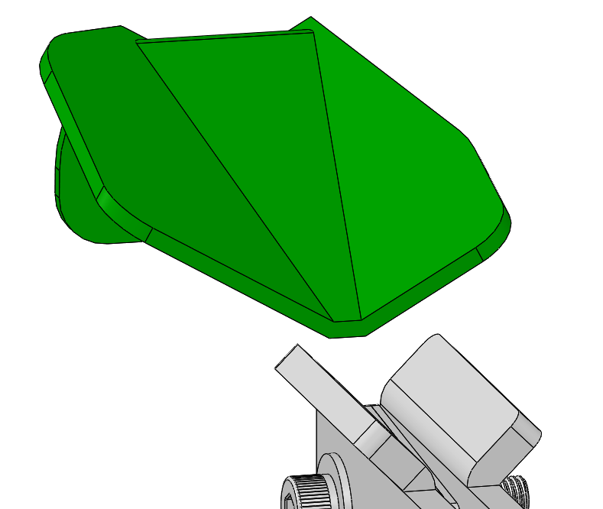
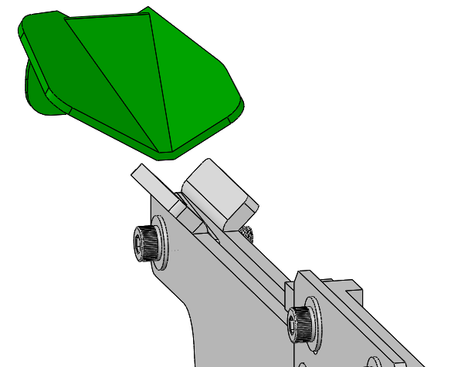
0.8~1.0mm

※ NOTICE ※
- Keep 0.8~1.0mm open space between V Chase and the end of the rail，and V Chase aligned to the center of the rail.

Adjust the Brush
1. Swing the brush to stay almost horizontal, loosen screw on the side of brush bracket.
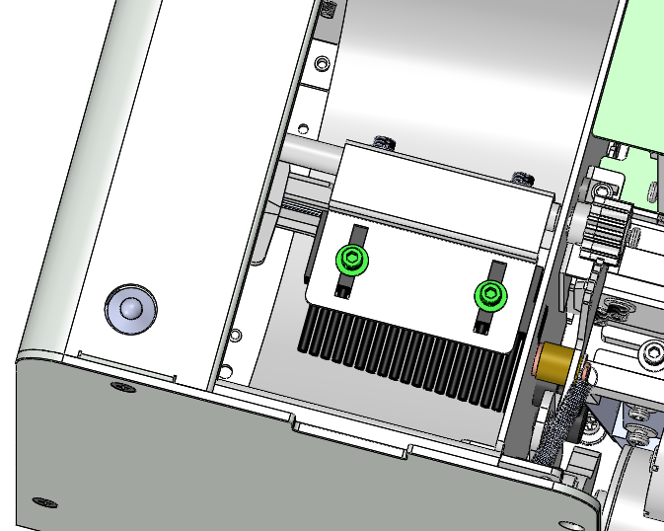
- Place 5~8 screws into the rail groove close to the holding plate rear end and loosen 2 screws on the side of the brush bracket. Swing the brush and adjust the height until the brush just touch the screw heads slightly, and tighten the screws after adjustment.
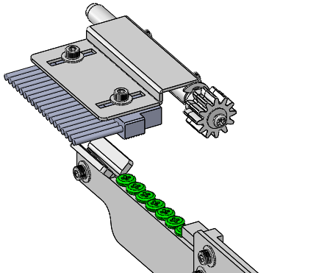
- When fix the brush position, keep suitable space form the Front Plate and Fixing Plate.
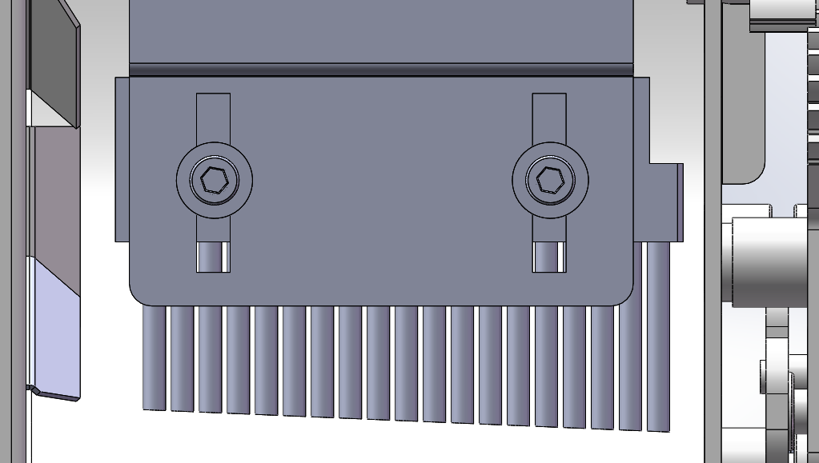
※ NOTICE ※
- After adjustment of the height of the brush, swing the brush by hand to make sure the movement runs smoothly.

- The brush length is inconsistently, please ensure the brush match rail when replace it.
- Brush bracket and driving rod must be parallel and fix to the center.
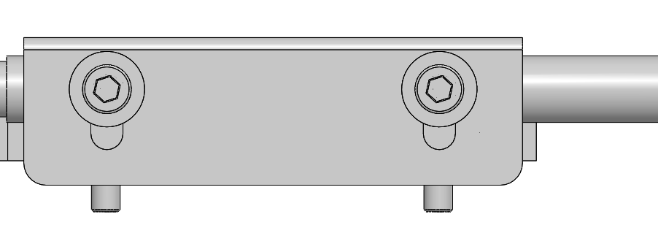

Method of Operation

Load Screws Into the Chamber
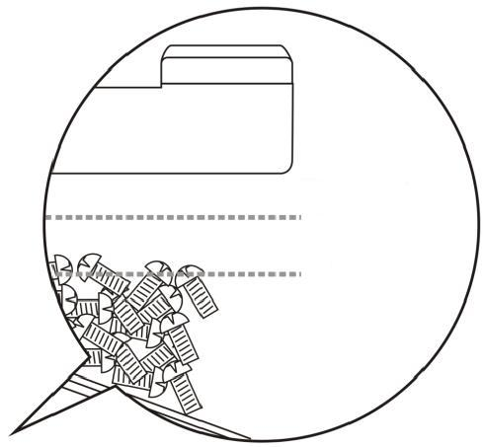
Turn off the power first, and open the Top Cover Box. Ensure the screws are loaded without foreign materials, pour in screws until they come up to 1~2mm below the top on both sides of the rails.
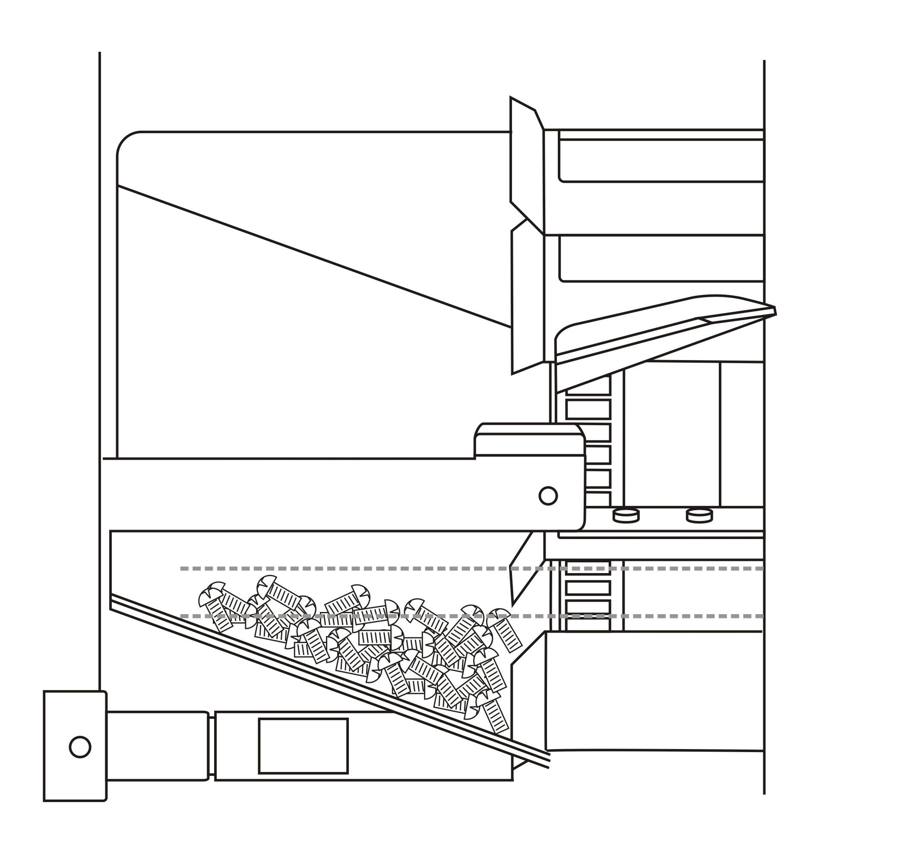

Can contain screws between 200~220cc. All objects other than applied screw are deemed as foreign material which should be removed first; or it will affect the performance of this machi

PICK UP SCREWS
Make sure the bit type onyour electric screwdriver matches the head of the screw, and the bit is magnetized before use.(Bit that not magnetized willnot stick with the screw andscrew willfall offafter picking up).
Hold the screwdriver and put the driver bit above the Bit Guideand push it straight down to "+" on top of thescrewas figure below.

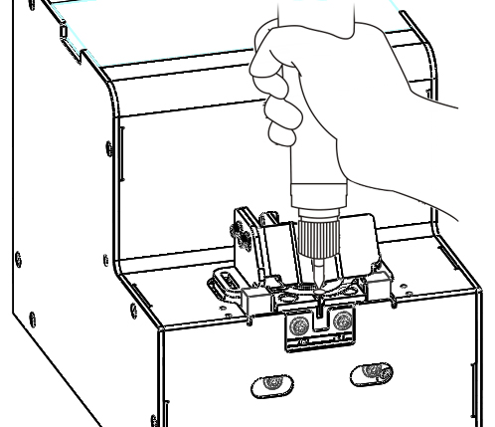

※CAUTION FOR THE ABOVE OPERATING ※
- Do not push the driver bit with too much force when picking up the screw, or it will adamge the Rail Assembly.
- Do not deliberately apply force on the Rail Assembly or it will damage the machine.

Counter interface operation
- Display interface diagram
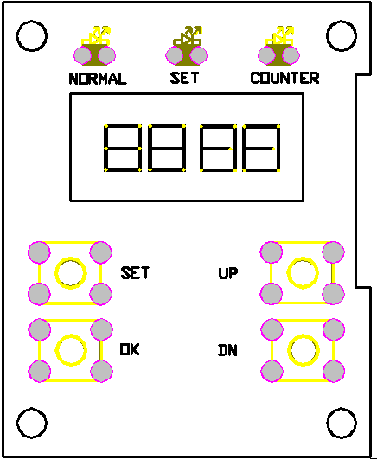

- Function of the Button
SET：Setting mode UP：Upper（Increase button）
OK：Confirm（Counter function） DOWN：Lower（Decrease button）

- Operation function and description
a. Count State：Automatic counting state and set the counting state, press the OK key to switch.。
b. Restore the factory state: In the standby or working state press the SET button and OK button at the same time for 3Sec, LED display flashes 3Sec and buzzing prompts the system to restore factory settings.

3. SET function description
3.1 In the standby or working state, press the SET button and hold 3Sec to enter the system to the number of settings, LED flashes and display as 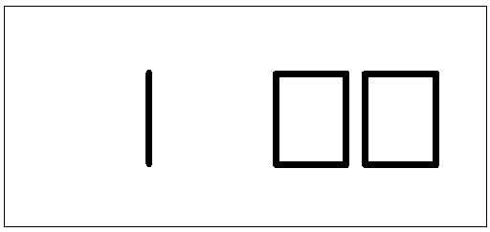，LED display flashes，then Press UP or DN to adjust the count number（System defaults as 00，number range of setting from 00~99），Press the OK button within 3sec or 3sec does not press the button; the system confirms the completion of the setting and makes a beep.

※ Note: If the setting count status is not displayed after setting, press the OK key to switch. 3.2 In the standby or working state, press SET button 2 times to enter the system of increasing,
easing mode，LED flashes and display as 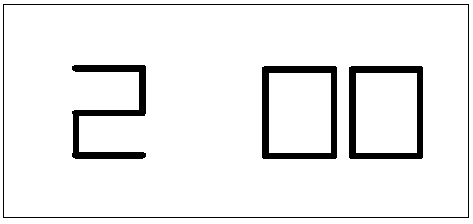，00 as increment mode，01 as decrement mode，press up or down button to change it，（System defaults as 00），Press the OK button within 3sec or 3sec does not press the button; The system confirms the completion of the setting and makes a beep.
※ Note: If the setting count status is not displayed after setting, press the OK key to switch.
3.3 In the standby or working state, press SET button 3 times to enter the system of Beep setting，LED flashes and display as 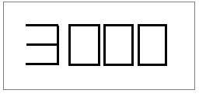，00 as turn on the beep,，01 as turn off the beep function，press UP or Down button to change it,（system defaults as 00），Press the OK button within 3sec or 3sec does not press the button; The system confirms the completion of the setting and makes a beep.

3.4 In the standby or working state, press SET button 4 times to enter the system of Vibration delay setting，LED flashes and display as 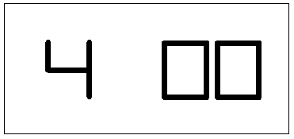，press UP or Down button to change the time of vibration delay setting（system defaults time of vibration delay time is based on the property of screw type, setting range as 01~12Sec,），Press the OK button within 3sec or 3sec does not press the button; The system confirms the completion of the setting and makes a beep.

3.5 In the standby or working state, press SET button 5 times to enter the system of Vibration intensity setting，LED flashes and display as 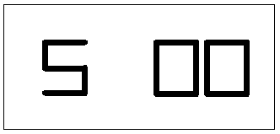，press UP or Down button to change the setting of vibration intensity（system defaults time of vibration intensity is based on the property of screw type, setting range as 01~10, 5V~10V, 10 steps in total, every 0.5V as 1
Step), Press the OK button within 3sec or 3sec does not press the button; The system confirms the completion of the setting and makes a beep.
3.6 In the standby or working state, press SET button 6 times to enter the system of roller delay time setting,，LED flashes and display as 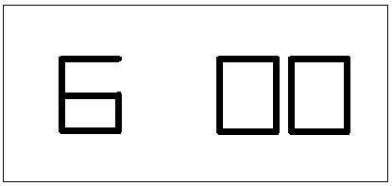，press UP or Down button to change the setting of delay time（system defaults time of roller delay time is based on the property of screw type，setting range as 01~12s），Press the OK button within 3sec or 3sec does not press the button; The system confirms the completion of the setting and makes a beep.
3.7 In the standby or working state, press SET button 7 times to enter the system of roller strength setting，LED flashes and display as 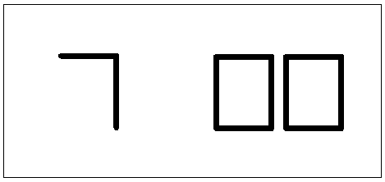，press UP or Down button to change the setting of strength value（system defaults strength of roller is based on the property of screw type, setting range as 01~10, 5V~10V, 10 steps in total, every 0.5V as 1 step），Press the OK button within 3sec or 3sec does not press the button; The system confirms the completion of the setting and makes a beep.
3.8 In the standby or working state, press SET button 8 times to enter the system of turntable strength setting, LED flashes and display as 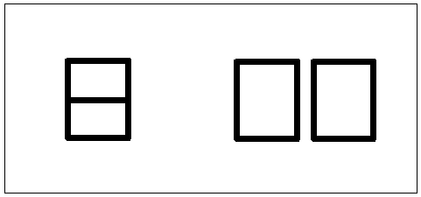，press UP or Down button to change the setting of speed value（system defaults strength is based on the property of screw type, setting range as 01~10），Press the OK button within 3sec or 3sec does not press the button; The system confirms the completion of the setting and makes a beep.
3.9 In the standby or working state, press SET button 12 times to enter the system of Vibration direction Forward or reverse setting，LED flashes and display as 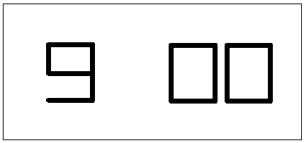，00 as forward，01 as reverse，press UP or Down button to change the setting（system defaults as 00），Press the OK button within 3sec or 3sec does not press the button; The system confirms the completion of the setting and makes a beep.

Troubleshooting
Please power off for examination once needed
Status | Caused | Solution
No action after power on or come with abnormal sounds | No AC power or loose cable | Check the power controller
No action after power on or come with abnormal sounds | Screws quantity too much | Take some screws out
No action after power on or come with abnormal sounds | Switch, motor, PCB malfunction | Replace Switch, motor or PCB
No action after power on or come with abnormal sounds | Screws fall in to the inside of machine | Clean it up
No action after power on or come with abnormal sounds | Infrared sensor not in the correct position | Adjust the infrared sensor
No action after power on or come with abnormal sounds | The infrared device is blocked | Clean it up
Roller chamber not rotate | Roller motor malfunction | Replace the roller motor
Roller chamber not rotate | Foreign stuck between the gears or gear crack | Remove foreign objects, replace components
Screw can’t slide out from screw feeder’s rail | The track clearance does not match the screw | Adjust the width of the gap between the left and right of the track
Screw can’t slide out from screw feeder’s rail | Screws block the gate way that brush can’t remove it | Adjust the height of brush
Screw can’t slide out from screw feeder’s rail | Gate door too small | Adjust the upper, right gate door
Screw can’t slide out from screw feeder’s rail | Push down plate not high enough | Adjust the position of push down plate
Screw can’t slide out from screw feeder’s rail | The vibration motor does not vibrate | Replace the motor of vibration
No signal output | Relays PCB burned or connection issue as cables fall | meter detects if there is a signal.。  - Signal indicates that the cable is disconnected and just need reconnect.  - No signal Description Relay burned, replace the relay board
No signal output | PCB got damaged or connection issue as cables fall | Use meter to check if there has 5V output。  - Signal indicates that the cable is disconnected  and just need reconnect.  - No signal Description PCB burned, need replace the PCB
Beep alarm with signal lights always on | PCB burned out | Replace the main PCB

MAINTENANCE & CLEANING
Turn off the POWER before performing maintenance and cleaning.
CLEANING AND MAINTENANCE THE BRUSH
Using the dry cotton to wipe the brush to remove the dust, Swing the brush by hand and adjust the height of the brush to make the brush in touch with screw heads. Replace the brush when brush hair is too worn and cannot wipe down screws in an improper position.
CLEANING AND MAINTENANCE THE RAIL
Withdraw the rail assembly, clean the rail groove and top of the rail (area for screws flow) with a clean thin cotton cloth soaked with alcohol or benzene. Use the Allen Key to check if the screws for the parts of rail assembly are fastened.
INTERIOR CLEANING
After cleaning the rail assembly, take out any screw or foreign material inside of machine, and clean whole interior parts, walls particularly the motor, PCB and gear to prevent effecting against machine functions.
OPTIONAL PARTS：
Please use genuine parts to ensure products quality and avoid influences caused against performance of this machine.
REMARK：
When using screw of special types or other than specified, please consult our distributors.
WARRANTY CARD
The warranty is valid for 12 months from purchase date (based on 8 working hours a day). Please contact your supplier during the warranty period for repair or maintenance.
- NOTE:
1. The service cost shall be considered as chargeable if the failure/cost was induced by any of the following conditions:
-Failure due to improper handling or un-authorized modification.
-Failure has nothing to do with the original design of the machine.
-Labor and parts cost to replace the consumable parts (brush, motor, rail assembly, etc.).

2. The WARRANTY will be void under any of the following conditions:
-Failure arising from a case or an accident beyond one’s control or Act of God.
-It has been modified, altered and/ or repaired by an unauthorized dealer, purchaser or third party.
-The serial number, warranty card has been altered, de-faced and /or removed.
-Failing to use genuine parts sold or recommended by the Company.

- Under this warranty, the company only provides service at any time during normal business hours. Should emergency service is required outside normal business hours, and such service if available will be provided with a charge on a per call rate basis.

4. The warranty is not transferable without the consent of the Company。
WARRANTY CARD
CUSTOMER：
TELEPHONE：
ADDRESS：
PURCHASE DATE：
DISTRIBUTOR：
MODEL NAME | AUTOMATIC SCREW FEEDER (PICK UP TYPE)
MODEL NO.
SERIAL NO.
SCREW SIZE | 1.2~5.0mm
SWITCHING ADAPTOR | DC IN 12V
MEASUREMENT | MACHINE : 182（L）*124（W）*147（H）mm
MEASUREMENT | EACH CARTON :282（L）*142（W）*201（H）mm
WEIGHT | N.W 3.1kg
WEIGHT | G.W 3.67kg
Remark:

